Casey Copeland
CSC-11
Survival RPG
11/3/2015

Introduction
Title: Survival RPG

The project is an assembly implementation of very basic coordinate system and battle system. These systems are key elements of a huge range of RPGs. Once set up, these systems are easy to build upon. For example, a shop could be added later or a more complex map system to make exploring a much more diverse world possible.
Summary
The c code version is about 200 lines of code, while the assembly version is about 500 lines. This 500 lines does not include the modulus function imported from a previous homework. The most challenging aspect was managing the string that was the visual aspect of the map. Registers are designed to deal with 4 bytes at a time, so writing to just one byte requires some byte manipulation to not change the values of the surrounding 3 bytes. As such, the use of bitwise operators were required for that. To not change the values of the surrounding 3 bytes, they were copied and combined with the single byte that was to be written. This causes the surrounding 3 bytes to be overwritten with the same value they started with before the write. For a non-threaded program, this is equivalent to writing 1 byte. For the combination of the 3 bytes and 1 byte, the inclusive or bitwise operator was used after ensuring the other bytes of each registered were zeroed out. Zeroing out the other bytes of the register was achievable with bit shifting. The one useful aspect of the 4 byte register dealing with an array of bytes is that multiple bytes of the array can be written at once. This is used during the initialization of the map since they are all set to the same character. For the entire project, it took a few days for the assembly code. The use of memory addresses to access structures as memory blocks complicated the assembly code greatly in comparison to c code.

Description
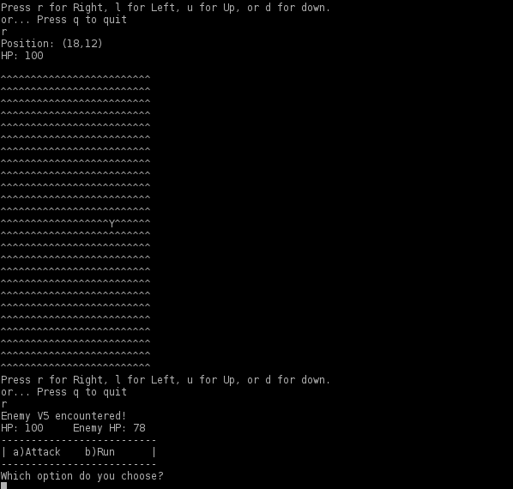
The program was developed piece by piece. The first piece created was the overall control flow. I checked to make sure that the while loop in main worked and would exit. After the general flow of it was laid out, more and more logic would be implemented. It went from creating battlers, to creating the battle function, and then finally to the text visual of seeing yourself traveling through the map. When errors occurred, gdb was used a lot to find where the segfault occurred. To make the code manageable, commenting was used to provide additional information. In particular, structures were commented to keep track of which order the variables were in an a structure. For functions, arguments required were typically commented to keep in mind which input it's meant to work with.
Screenshots

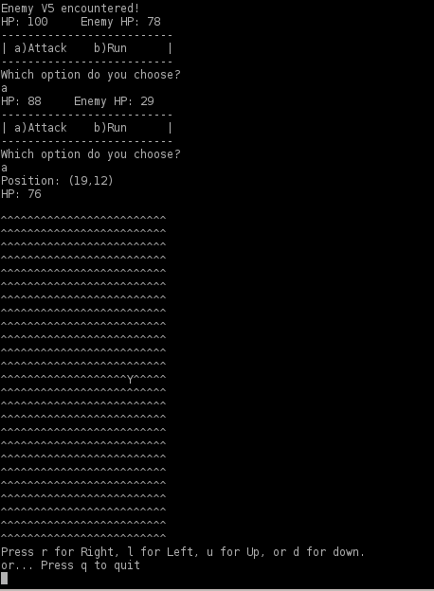

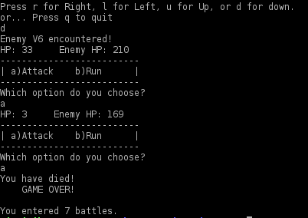

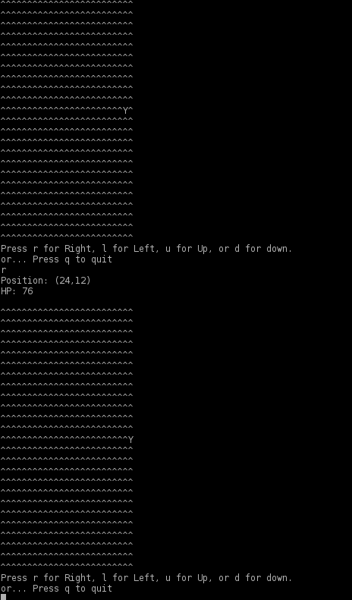

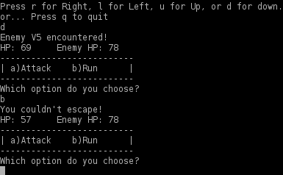

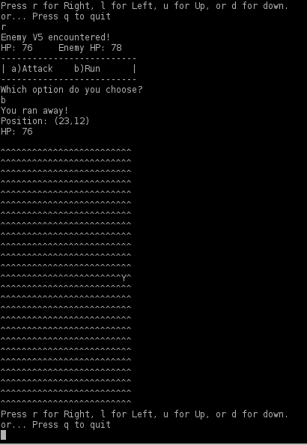

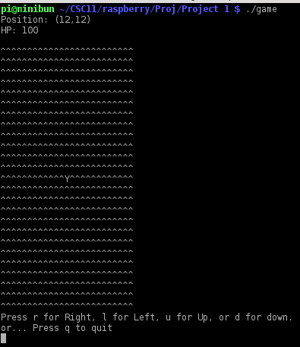

Flow Chart
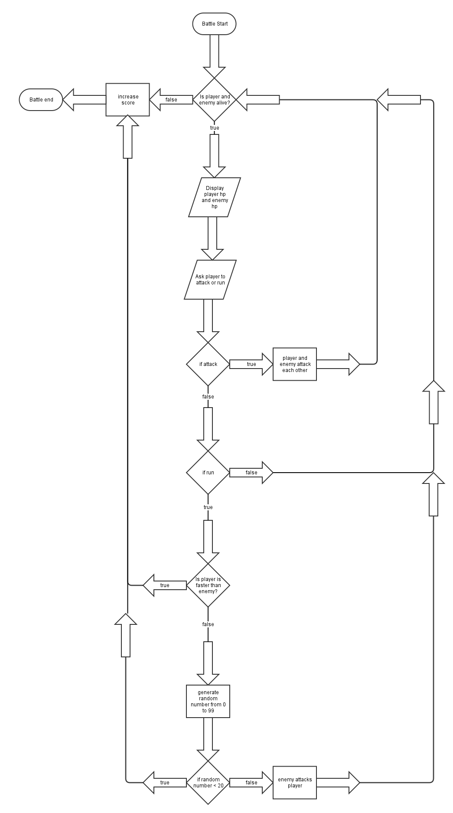
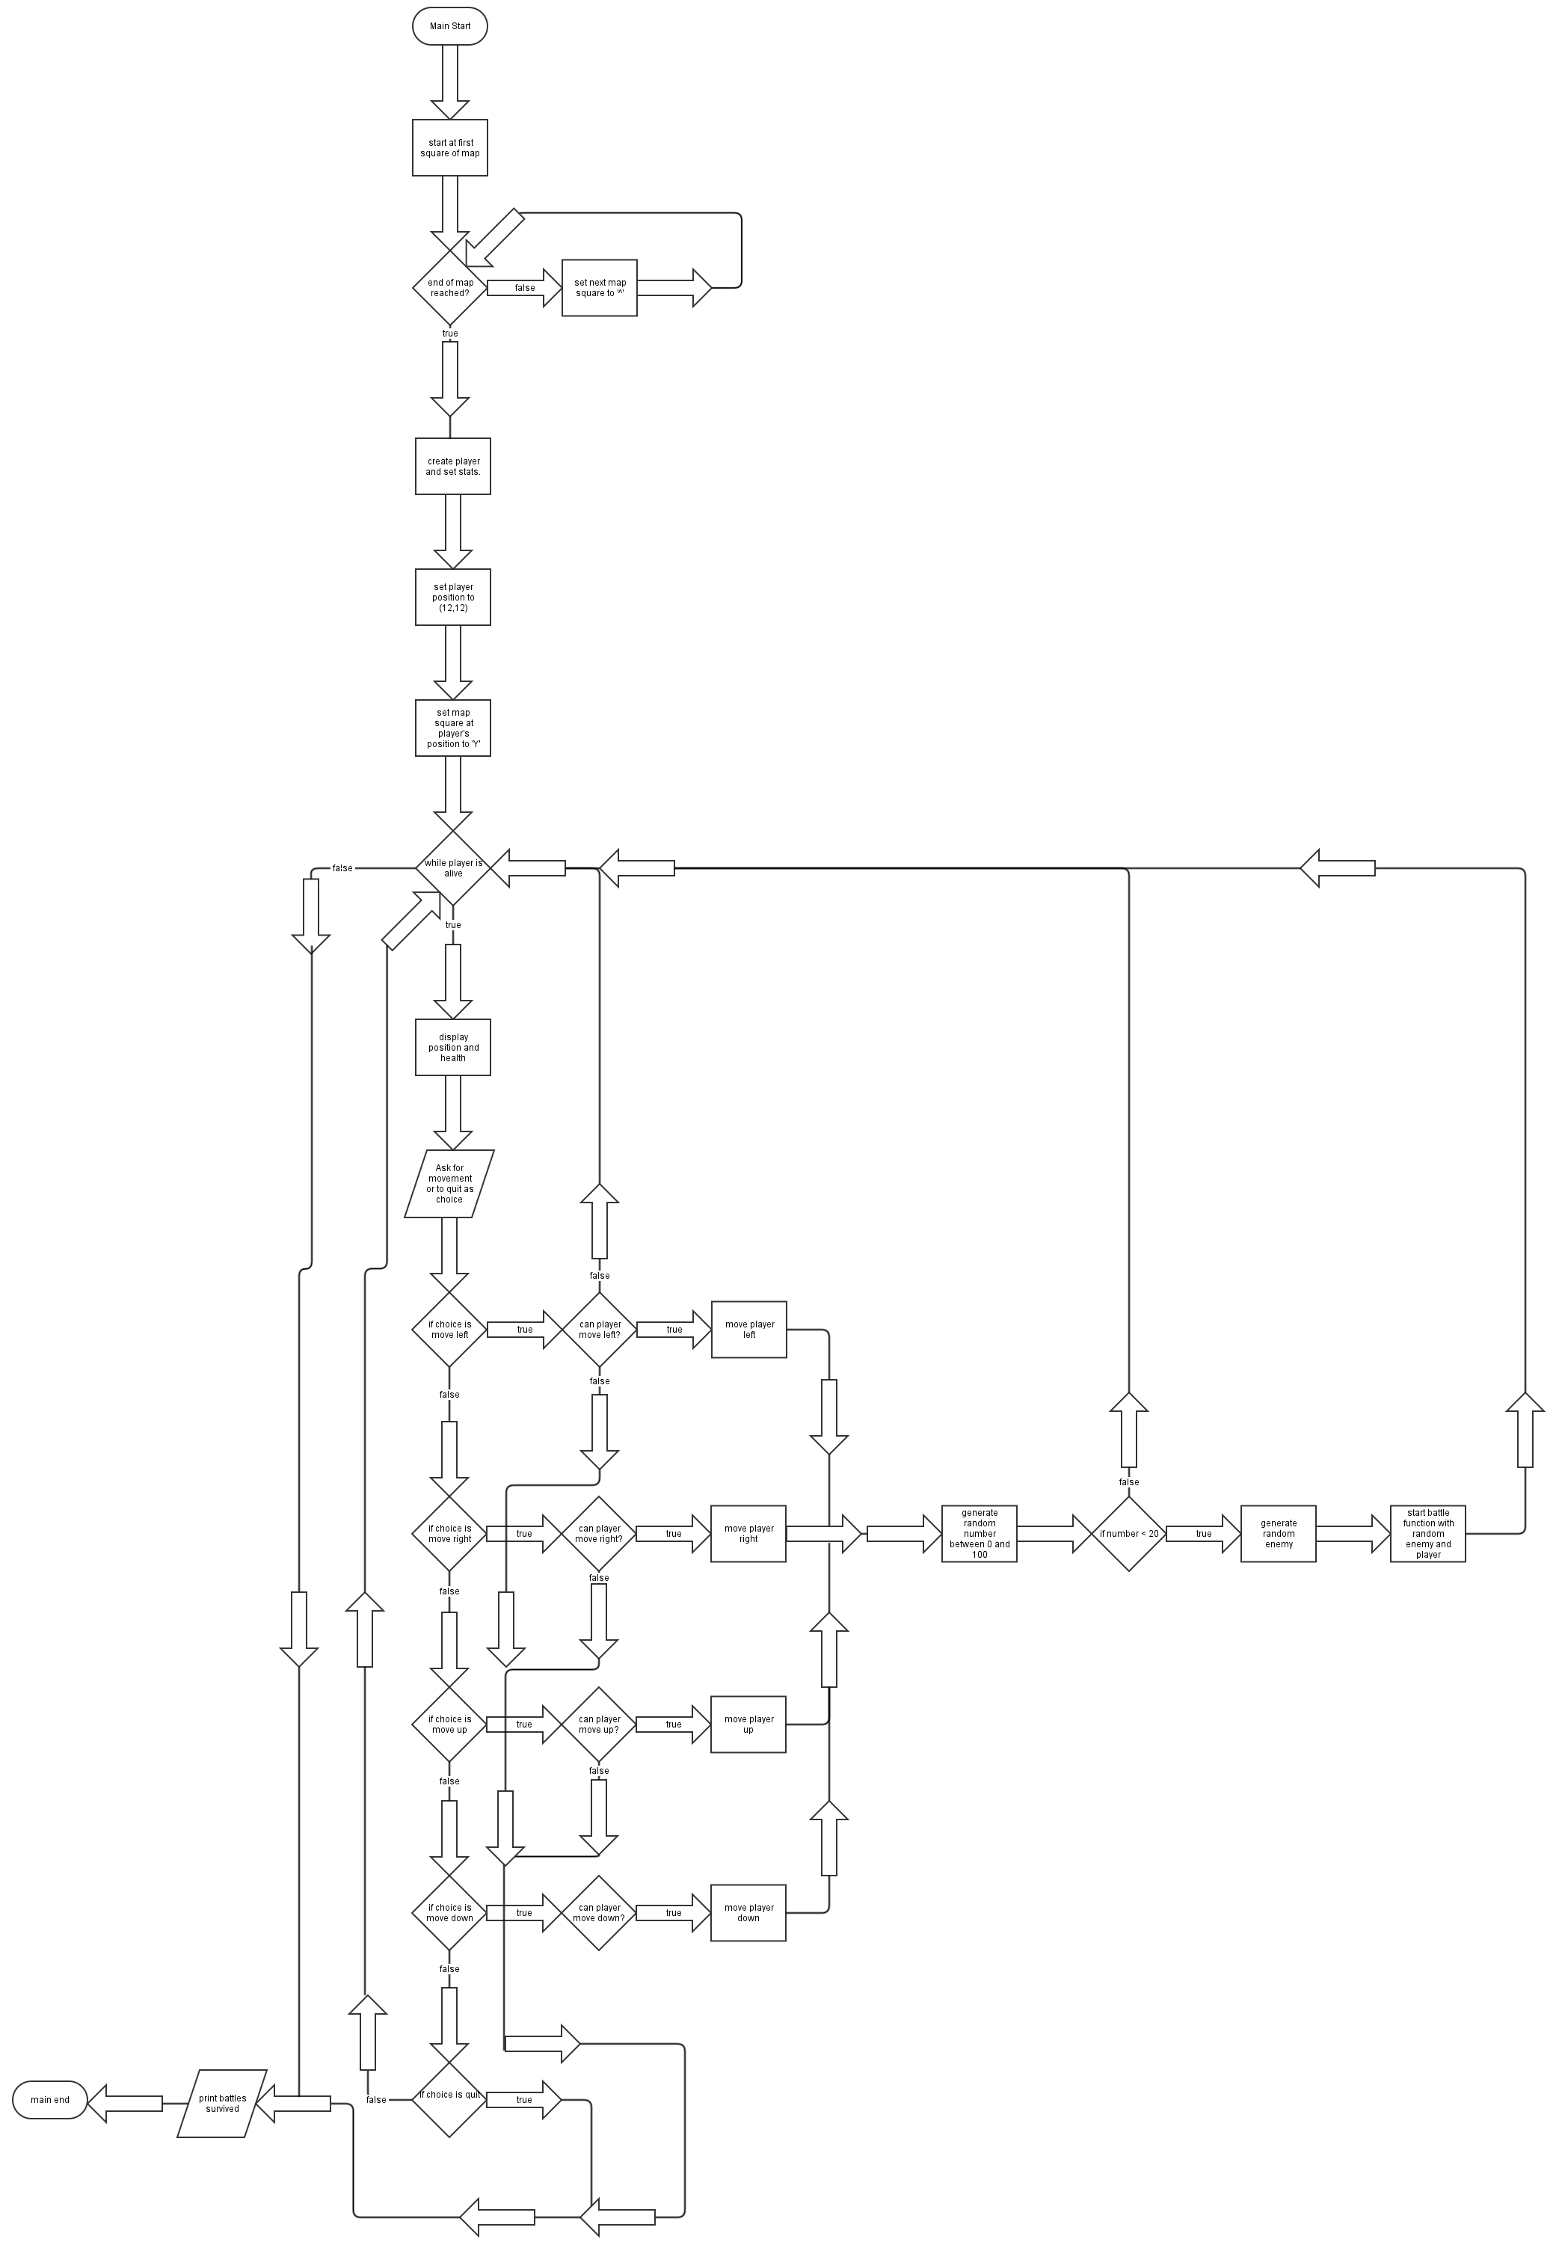

Pseudo Code
map is an array of ASCII characters
position is a point (x,y)
stats are hp, attack, defense, and speed
battlers are a combination of stats, position, and a name
hit (attacker, receiver) {
if attacker's attack not greater than the receiver's defense:
receiver lost 1 hp
else:
receiver's hp drops by the difference between the two
}
battle (player, enemy) {
print enemy encountered
while enemy and player are alive:
ask player whether to run or attack
if attack:
have player hit enemy
have enemy hit player
if run:
if run successful
print run successful
quit battle
else have enemy hit player
print run failed
have enemy hit player
}
display_map (map) {
for each square in map, print square
}
main() {
Both player and enemy are battlers.
while player is alive:
display position, hp, and map
ask player which option he/she chooses
if player choses to move left, move player left
if player chooses to move right, move player right
if player chooses to move up, move player up
if player chooses to move down, move player down
if player chooses to quit, print battles encountered and quit
if player has chosen any of the movements above,
if player would've moved outside the map
prevent the move
else
randomly decide if to generate a random enemy.
If random enemy generated,
start battle between player and random enemy
if player died
print game over
print battles encountered
quit
}
Major Variables
Type | Variable Name | Description | Location
Byte array | map | Visual representation of Map as text | main.s
Byte | score | Number of battles encountered | main.s
Battler Array | battlers | Array of all battlers needed to be allocated at once. One for the player and one for the enemy. | main.s

Structures
Coordinate: Contains the position of something on the map.
byte X
byte Y
Stats: Contains all the stats necessary for calculations in battle.
byte HP
byte Attack
byte Defense
byte Speed
Battler: A structure containing all the data necessary for the main player as well as enemies.
Stats stats
Coordinate position
String name

Language Constructs
C-level view of assembly
for loop: used to initialize the map
while loop: used for main loop and battle loop
if else: used in many places, such as checking if a player is faster than the enemy during attempting to run
switch-case: used for choices in main loop and battle
function calls: used in many places, such as for printing, and for doing battling
assembly level view
branching: used everywhere, including main loop
printf: used for printing, such as in main loop
scanf: used for getting input, such as in reply to asking what to do in main loop
mov: used everywhere, including main loop
.balign 4: used for most data to align it
.global: used to make a function or data accessible to other assembly files during linking
push: used for functions that required more than 4 arguments, such as initBattler
pop: used for same reason as pop, but to take out the arguments instead of placing them
ldr: used in many places to load from memory or to load values too big for a mov
add: used for adding, such as pointers offset
sub: used for subtracting, such as decreasing health during an attack
lsl: used to shift bits around for dealing with the map, which was a byte arrray
lsr: same as lsl, but shifts bits to the right instead of left
orr, used to combine the bits to two registers when dealing with the map, one register holding 3 bytes
that are already in the map, and the other holding the byte to write. Mnemonic for bitwise operator inclusive or.
.macro/.endm: used to create a copy and paste macro similar to what the c preprocessor can do.
labels: used to name sections of code to jump to in a branch
.asciiz: used to make null terminated strings
.ascii: used to make a string
.byte: used to put my name into the executable as seen in the end of main.s. Also used for data such as inputChar
mul: used for multiplication for finding which map index an (x,y) coordinate is in mapCoordinateToIndex

memory addresses: used to refer to allocated variables with label names
.text: used to denote code section and constants
.data: used to denote data section
.include: used to include other assembler files that contain macros and symbols that the linker doesn't
deal with
.skip: used to allocate map as a byte array
References
Code from the modulus homework was placed into the project to use it as part of the range for random number generation and for the display of the map to make sure each row gets printed on it's own line. In addition to that, a few functions from the standard c library were used. The c functions used were printf, scanf, getchar, srand, and rand. printf and scanf were imported for the purpose of output and input respectively. The fucntion getchar was necessary to keep the input and output working as expected by clearing out any newlines left by scanf. For random values, srand, rand, and time was imported so that I could make enemy encounters random.
Program
main.c
#include<stdio.h>
#include<time.h>

#define MAP_WIDTH 25
#define MAP_SIZE 625

char map [MAP_SIZE];
int score = 0;

struct Coord {
int x;
int y;
};

struct Stats {
int hp;
int attack;
int defense;
int speed;
};

struct Battler {
struct Stats stats;
struct Coord pos;
const char* name;
};

void attack (struct Battler* attacker,struct Battler* receiver) {
if (attacker->stats.attack > receiver->stats.defense) {
receiver->stats.hp-=attacker->stats.attack-receiver->stats.defense;
} else {
receiver->stats.hp-=1;
}
}
void battle (struct Battler* player,struct Battler* enemy) {
char choice;
int run;
int odds;
printf("%s encountered!\n",enemy->name);
while (1) {
if (player->stats.hp <= 0) {
score+=1;
return;
} else if (enemy->stats.hp <= 0) {
score+=1;
return;
}
printf("HP: %d Enemy HP: %d\n",player->stats.hp,enemy->stats.hp);
printf("-------------------------\n");
printf("| a)Attack b)Run |\n");
printf("-------------------------\n");
printf("Which option do you choose?\n");
scanf("%c",&choice);
getchar();
switch(choice) {
case 'a':
case 'A':
attack(player,enemy);
attack(enemy,player);
break;
case 'b':
case 'B':
if (player->stats.speed > enemy->stats.speed) {
printf("You ran away!\n");
run = 1;
score+=1;
} else {
odds = rand() % 100;
if (odds < 20) {
printf("You ran away!\n");
run = 1;
score+=1;
} else {
printf("You couldn't escape!\n");
attack(enemy,player);
}
}
break;
}
if (run == 1) {
break;
}
}
}

void initBattle (struct Battler* player, int hp, int attack,
int defense, int speed, const char* name) {
struct Battler enemy;
enemy.stats.hp = hp;
enemy.stats.attack = attack;
enemy.stats.defense = defense;
enemy.stats.speed = speed;
enemy.name = name;
battle(player,&enemy);
}

void chanceEncounter (struct Battler* player) {
int odds = rand() % 100;
if (odds < 15) {
odds = rand() % 6;
switch(odds) {
case 0:
initBattle(player,50,11,2,5,"Enemy V1");
break;
case 1:
initBattle(player,55,12,2,5,"Enemy V2");
break;
case 2:
initBattle(player,60,13,3,5,"Enemy V3");
break;
case 3:
initBattle(player,67,15,5,6,"Enemy V4");
break;
case 4:
initBattle(player,78,17,2,7,"Enemy V5");
break;
case 5:
initBattle(player,210,35,10,8,"Enemy V6");
break;
}
}
}

int main() {
struct Battler player;
char choice;
int i;
srand(time(NULL));
for (i=0;i<MAP_SIZE;++i) {
map[i] = '^';
}
player.stats.hp = 100;
player.stats.attack = 51;
player.stats.defense = 5;
player.stats.speed = 6;
player.pos.x = 12;
player.pos.y = 12;
map[player.pos.x+MAP_WIDTH*player.pos.y]='Y';
player.name = "Hero";
while (1) {
if (player.stats.hp <= 0) {
printf("You have died!\n GAME OVER!\n\n");
printf("You entered %d battles.\n",score);
return;
}
printf("Position: (%d,%d)\n",player.pos.x,player.pos.y);
printf("HP: %d\n",player.stats.hp);
for (i=0;i<MAP_SIZE;++i) {
if (i%MAP_WIDTH == 0) {
printf("\n");
}
printf("%c",map[i]);
}
printf("\n\nPress r for Right, l for Left, u for Up, or d for down.\n");
printf("or... Press q to quit\n");
scanf("%c",&choice);
getchar();
switch(choice) {
case 'r':
case 'R':
player.pos.x+=1;
if (player.pos.x >= MAP_WIDTH) {
player.pos.x=MAP_WIDTH-1;
break;
}
map[player.pos.x-1+MAP_WIDTH*player.pos.y]='^';
map[player.pos.x+MAP_WIDTH*player.pos.y]='Y';
chanceEncounter(&player);
break;
case 'l':
case 'L':
player.pos.x-=1;
if (player.pos.x < 0) {
player.pos.x=0;
break;
}
map[player.pos.x+1+MAP_WIDTH*player.pos.y]='^';
map[player.pos.x+MAP_WIDTH*player.pos.y]='Y';
chanceEncounter(&player);
break;
case 'u':
case 'U':
player.pos.y-=1;
if (player.pos.y < 0) {
player.pos.y=0;
break;
}
map[player.pos.x+MAP_WIDTH*(player.pos.y+1)]='^';
map[player.pos.x+MAP_WIDTH*player.pos.y]='Y';
chanceEncounter(&player);
break;
case 'd':
case 'D':
player.pos.y+=1;
if (player.pos.y >= MAP_WIDTH) {
player.pos.y=MAP_WIDTH-1;
break;
}
map[player.pos.x+MAP_WIDTH*(player.pos.y-1)]='^';
map[player.pos.x+MAP_WIDTH*player.pos.y]='Y';
chanceEncounter(&player);
break;
case 'q':
case 'Q':
printf("You entered %d battles.\n",score);
return 0;
}
}
}
main.s

.data

.global score
.balign 4
score: .word 0

mapBoundHigh = 25

.balign 4
/*map is a square that's top left tile or coordinate is (0,0)*/
map: .skip mapBoundHigh*mapBoundHigh

/* memory allocation for battlers */
.balign 4
battlers: .skip sizeOfBattler*2

.balign 4
inputChar: .byte 0

.balign 4
return: .word 0

.balign 4
.text
.include "battler.s"
.include "usefulMacros.s"
.global main

/*returns back to main loop after battle*/
.macro initBattle HP, Attack, Defense, Speed, NameAddress
mov R1, #\HP
mov R2, #\Attack
mov R3, #\Defense
mov R0, #\Speed
push {R0, R1, R2, R3}
ldr R0, =(battlers+sizeOfBattler)
mov R1, #0
mov R2, #0
ldr R3, =\NameAddress
bl initBattler
ldr R1, =(battlers+sizeOfBattler)
ldr R0, =battlers
ldr LR, =mainLoop
b battle
.endm
.macro moveSwapMapBytes difference
ldr R0, =(battlers+sizeOfStats)
mov R1, #mapBoundHigh
bl mapCoordinateToIndex
ldr R1, =map
add R0, R0, R1
add R2, R0, #\difference
#swap characters in map
ldr R1, [R0]
ldr R3, [R2]
str R1, [R2]
str R3, [R0]
.endm

main:
/* save return address*/
ldr R5, =return
str LR, [R5]

/*initialization*/
mov R0, #0
bl time
bl srand
/* initialize map*/
ldr R0, =map
/* ASCII '^' */
mov R1, #0x5E
ldr R2, =(mapBoundHigh*mapBoundHigh)
bl mapInit
/* initializes main player*/
mov R1, #100
mov R2, #51
mov R3, #5
mov R0, #6
push {R0, R1, R2, R3}
ldr R0, =battlers
mov R1, #12
mov R2, #12
ldr R3, =playerName
bl initBattler
ldr R0, =(battlers+sizeOfStats)
mov R1, #mapBoundHigh
bl mapCoordinateToIndex
ldr R1, =map
add R1, R1, R0
/*shifts map pointer over 3 bytes so write places
'Y' in correct byte*/
sub R1, R1, #3
/*load map bytes for later inclusive or*/
ldr R2, [R1]
lsl R2, #8
lsr R2, #8
/* player represented by 'Y' */
mov R3, #0x59
lsl R3, #24
/*keep map bytes since registers are 4 bytes*/
orr R3, R2
str R3, [R1]

mainLoop:
ldr R5, =battlers
ldr R0, [R5]
cmp R0, #0
ble gameOver
ldr R0, =mainLoopStatusMessage
ldr R3, [R5]
add R5, R5, #sizeOfStats
ldr R1, [R5]
add R5, R5, #(sizeOfCoord/2)
ldr R2, [R5]
bl printf
ldr R0, =map
mov R1, #mapBoundHigh
ldr R2, =(mapBoundHigh*mapBoundHigh)
bl mapDisplay
ldr R0, =mainLoopControlsMessage
bl printf
ldr R0, =mainInputFormat
ldr R1, =inputChar
bl scanf
/* remove newline still in buffer
(newline in buffer will printf to print twice when loop repeats)*/
bl getchar

/* compare to ASCII L */
compareBothCase 0x4C, moveLeft
/* compare to ASCII R */
compareBothCase 0x52, moveRight
/* compare to ASCII U */
compareBothCase 0x55, moveUp
/* compare to ASCII D */
compareBothCase 0x44, moveDown
/* compare to ASCII Q*/
compareBothCase 0x51, endMainLoop
b mainLoop
moveLeft:
ldr R2, =(battlers+sizeOfStats)
ldr R1, [R2]
sub R3, R1, #1
/*branch on overflow (subtracting from 0)*/
cmp R3, R1
bhi mainLoop
str R3, [R2]
moveSwapMapBytes 1
b chanceEncounter
moveRight:
ldr R2, =(battlers+sizeOfStats)
ldr R1, [R2]
add R3, R1, #1
cmp R3, #(mapBoundHigh-1)
bhi mainLoop
str R3, [R2]
moveSwapMapBytes (-1)
b chanceEncounter
moveDown:
ldr R2, =(battlers+sizeOfStats+sizeOfCoord/2)
ldr R1, [R2]
add R3, R1, #1
cmp R3, #(mapBoundHigh-1)
bhi mainLoop
str R3, [R2]
moveSwapMapBytes (-mapBoundHigh)
b chanceEncounter
moveUp:
ldr R2, =(battlers+sizeOfStats+sizeOfCoord/2)
ldr R1, [R2]
sub R3, R1, #1
/*branch on overflow (subtracting from 0)*/
cmp R3, R1
bhi mainLoop
str R3, [R2]
moveSwapMapBytes mapBoundHigh
b chanceEncounter
chanceEncounter:
bl rand
mov R1, #100
bl mod
/* 5 percent chance of enemy encounter */
cmp R0, #15
blo genEnemy
b mainLoop
genEnemy:
bl rand
mov R1, #6
bl mod
enemyOne:
cmp R0, #0
bne enemyTwo
initBattle 50 11 2 5 enemyOneName
enemyTwo:
cmp R0, #1
bne enemyThree
initBattle 55 12 2 5 enemyTwoName
enemyThree:
cmp R0, #2
bne enemyFour
initBattle 60 13 3 5 enemyThreeName
enemyFour:
cmp R0, #3
bne enemyFive
initBattle 67 15 5 6 enemyFourName
enemyFive:
cmp R0, #4
bne enemySix
initBattle 78 17 2 7 enemyFiveName
enemySix:
initBattle 210 35 10 8 enemySixName
gameOver:
ldr R0, =deathMessage
bl printf
endMainLoop:
ldr R0, =scoreMessage
ldr R1, =score
ldr R1, [R1]
bl printf
/*return*/
ldr R5, =return
ldr LR, [R5]
bx LR

/*constants*/
.balign 4
mainLoopStatusMessage:
.ascii "Position: (%d,%d)\n"
.asciz "HP: %d\n"
mainLoopControlsMessage:
.ascii "\nPress r for Right, l for Left, u for Up, or d for down.\n"
.asciz "or... Press q to quit\n"
deathMessage:
.asciz "You have died!\n GAME OVER!\n\n"
scoreMessage:
.asciz "You entered %d battles.\n"
.balign 4
mainInputFormat: .asciz "%c"

.global printf
.global scanf
.global getchar
.global srand
.global rand
.global time

.balign 4
playerName: .asciz "Hero"
.balign 4
enemyOneName: .asciz "Enemy V1"
.balign 4
enemyTwoName: .asciz "Enemy V2"
.balign 4
enemyThreeName: .asciz "Enemy V3"
.balign 4
enemyFourName: .asciz "Enemy V4"
.balign 4
enemyFiveName: .asciz "Enemy V5"
.balign 4
enemySixName: .asciz "Enemy V6"

.byte 0x43, 0x61, 0x73, 0x65, 0x79, 0x20, 0x20, 0x43
.byte 0x6F, 0x70, 0x65, 0x6C, 0x61, 0x6E, 0x64, 0x00
attack.s
.balign 4
.text

.global attack
/*args
R0 is pointer to attacker
R1 is pointer to receiver*/
attack:
/*HP*/
ldr R2, [R1]
/*Defense*/
ldr R3, [R1,#8]
/*Attack*/
ldr R0, [R0,#4]
cmp R0, R3
bls oneDamage
/*normal damage calculation*/
sub R0, R0, R3
sub R2, R2, R0
b attackReturn
oneDamage:
mov R3, #1
sub R2, R2, R3
attackReturn:
str R2, [R1]
bx LR
battle.s
.data
.balign 4
return: .word 0
.balign 4
inputChar: .word 0

.balign 4
.text
.global battle

.include "battler.s"
.include "usefulMacros.s"

/* args:
R0 is pointer to controllable battler
R1 is pointer to AI battler */
battle:
/*save return address*/
ldr R5, =return
str LR, [R5]

mov R5, R0
mov R6, R1
ldr R0, =encounterMessage
add R1, #(sizeOfStats+sizeOfCoord)
ldr R1, [R1]
bl printf
battleLoop:
mov R0, R5
ldr R0, [R0]
mov R1, R6
ldr R1, [R1]
cmp R1, #0
ble battleLoopEnd
cmp R0, #0
ble battleLoopEnd
ldr R0, =battleLoopMessage
ldr R1, [R5]
ldr R2, [R6]
bl printf
ldr R0, =inputFormat
ldr R1, =inputChar
bl scanf
bl getchar
/* compare to A */
compareBothCase 0x41 attackEnemy
/* compare to B */
compareBothCase 0x42 run
b battleLoop
attackEnemy:
mov R0, R5
mov R1, R6
bl attack
mov R1, R5
mov R0, R6
bl attack
b battleLoop
run:
mov R0, R5
ldr R0, [R0,#12]
mov R1, R6
ldr R1, [R1,#12]
cmp R0, R1
bhi runSuccess
bl rand
mov R1, #100
bl mod
/* 20 percent chance of running when slower*/
cmp R0, #20
blo runSuccess
ldr R0, =runFailMsg
bl printf
mov R1, R5
mov R0, R6
bl attack
b battleLoop
runSuccess:
ldr R0, =runSuccessMsg
bl printf
battleLoopEnd:
ldr R0, =score
ldr R1, [R0]
add R1, R1, #1
str R1, [R0]
/*return*/
ldr R5, =return
ldr LR, [R5]
bx LR

.balign 4
encounterMessage:
.asciz "%s encountered!\n"
.balign 4
battleLoopMessage:
.ascii "HP: %d Enemy HP: %d\n"
.ascii "--------------------------\n"
.ascii "| a)Attack b)Run |\n"
.ascii "--------------------------\n"
.asciz "Which option do you choose?\n"
.balign 4
inputFormat: .asciz "%c"
runFailMsg: .asciz "You couldn't escape!\n"
runSuccessMsg: .asciz "You ran away!\n"

.global printf
.global scanf
.global getchar
.global rand
battler.s
/* File for inclusion to make symbols available to assembler
(.global is for making symbols available to linker) */

/* STRUCTURES
---------------------------------*/
/* coordinate structure
1 word X
1 word Y*/
sizeOfCoord=8
/* stats structure
1 word HP
1 word Attack
1 word Defense
1 word Speed */
sizeOfStats=16
/* battler structure layout
1 stats
1 coordinate position
1 word (address to string) name */
sizeOfBattler=sizeOfStats+sizeOfCoord+4
battlerInit.s
.data
.balign 4
return2: .word 0

.balign 4
.text
.include "battler.s"

/* Init Functions */
.global initCoord
.global initBattler
.global initStats

/*args:
R0 is memory pointer to coordinate structure
R1 is X value
R2 is Y value
*/
initCoord:
/* X = 0 */
str R1, [R0]
/* Y = 0 */
str R2, [R0,#4]
bx LR

/*args:
R0 is memory pointer to stats structure
R1 is HP
R2 is Attack
R3 is Defense
on stack: Speed
*/
initStats:
/*set HP*/
str R1, [R0]
/*set Attack*/
str R2, [R0,#4]
/*set Defense */
str R3, [R0,#8]
mov R5, R0
pop {R0, IP}
/*set Speed */
str R0, [R5,#12]
bx LR

/*args:
R0 is memory pointer to battler structure
R1 is coordinate X
R2 is coordinate Y
R3 is pointer to name
on stack: Speed, HP, Attack,Defense
*/
initBattler:
/* save return address */
ldr R5, =return2
str LR, [R5]
add R0, R0, #sizeOfStats
bl initCoord
add R0, R0, #sizeOfCoord
str R3, [R0]
sub R0, R0, #(sizeOfStats+sizeOfCoord)
mov R5, R0
pop {R0, R1, R2, R3}
push {R0, IP}
mov R0, R5
bl initStats
/* return */
ldr R5, =return2
ldr LR, [R5]
bx LR
map.s
.data
mapWidth: .word 0
mapSize: .word 0
mapPointer: .word 0
mapStart: .word 0
mapEnd: .word 0
return: .word 0
.balign 4
.text
.global mapInit
/* args:
R0 = address to char array of map to fill
R1 = character to fill array of map with
R2 = size of map*/
mapInit:
mov R3, R0
add R3, R3, R2
mov R4, R1
/*R1 is 4 bytes, so fill all 4 bytes with same pattern*/
lsl R4, #8
orr R1, R4
mov R4, R1
lsl R4, #16
orr R1, R4
mapInitLoop:
cmp R0, R3
bhs mapInitEnd
str R1, [R0]
add R0, R0, #4
b mapInitLoop
mapInitEnd:
bx LR

.global mapDisplay
/* args:
R0 is address to char array of map
R1 is map width
R2 is map size */
mapDisplay:
ldr R3, =return
str LR, [R3]
ldr R3, =mapStart
str R0, [R3]
ldr R3, =mapPointer
str R0, [R3]
ldr R3, =mapEnd
add R0, R0, R2
str R0, [R3]
ldr R3, =mapWidth
str R1, [R3]
ldr R3, =mapSize
str R2, [R3]
ldr R0, =mapPointer
ldr R0, [R0]
mapDisplayLoop:
ldr R3, =mapEnd
ldr R3, [R3]
cmp R0, R3
beq mapDisplayEnd
ldr R1, =mapStart
ldr R1, [R1]
sub R0, R0, R1
ldr R1, =mapWidth
ldr R1, [R1]
bl mod
cmp R0, #0
bne printMapSquare
ldr R0, =newLineMessage
bl printf
printMapSquare:
ldr R0, =mapSquareMessage
ldr R1, =mapPointer
ldr R1, [R1]
ldr R1, [R1]
bl printf
ldr R0, =mapPointer
ldr R1, [R0]
add R1, R1, #1
str R1, [R0]
mov R0, R1
b mapDisplayLoop
mapDisplayEnd:
ldr LR, =return
ldr LR, [LR]
bx LR

.global mapCoordinateToIndex
/*args:
R0 is pointer to coordinate
R1 is map width*/
mapCoordinateToIndex:
ldr R3, =return
str LR, [R3]
mov R2, R0
add R2, R2, #4
ldr R0, [R0]
ldr R2, [R2]
mul R3, R2, R1
add R0, R0, R3
ldr LR, =return
ldr LR, [LR]
bx LR

.global mapSwapCoordinates
/*args:
R0 is pointer to coordinate
R1 is pointer to other coordinate
R2 is map width*/
mapSwapCoordinates:
ldr R3, =return
str LR, [R3]
ldr R3, =mapWidth
str R2, [R3]
mov R4, R1
mov R1, R2
bl mapCoordinateToIndex
mov R3, R0
mov R0, R4
mov R4, R3
ldr R1, =mapWidth
ldr R1, [R1]
bl mapCoordinateToIndex
ldr R2, [R4]
ldr R1, [R0]
str R2, [R0]
str R1, [R4]
ldr LR, =return
ldr LR, [LR]
bx LR

mapSquareMessage: .asciz "%c"
newLineMessage: .asciz "\n"
mod.s
.text
.global mod

/* args:
R0 unsigned value being divided, remainder should be in here at end
R1 unsigned divisor, assumed to be greater than 1 */
mod:
mov R2, R1
cmp R1, R0
bgt end
b mod_start
/*bit shift left*/
modLoop:
cmp R1, R0
bhi result
mod_start:
sub R0, R0, R1
lsl R1, #1
b modLoop
/*subtract and bit shift right*/
result:
lsr R1, #1
cmp R1, R2
blo end
cmp R1, R0
bhi result
sub R0, R0, R1
b result
end:
bx LR
usefulMacros.s
.macro compareBothCase upperChar, trueBranch
ldr R0, =inputChar
ldr R0, [R0]
cmp R0, #\upperChar
beq \trueBranch
cmp R0, #(\upperChar+0x20)
beq \trueBranch
.endm

